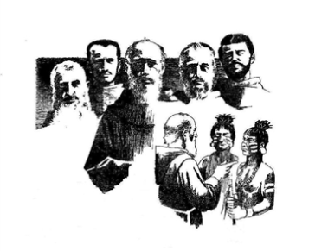

Fraternal Visitation Report

St. Anthony of Padua, Milton Florida

April 20, 2024

Jeane Swaynos, OFS

Regional Minister

Three active members present: Shelly Zecckine, Minister Louise Roberts, Secretary, Louise Stuffibeam, Councilor, Margie Butler, Affiliate, and Leo Stufflebeam, Affiliate

Also present: Msgr. Michael Reed from St. Rose of Lima parish, Fr. Christian Plancher, SMM/Phd from St, Rose of Lima Parish

Joseph Bedics, soon to be transfer from Pennsylvania

Preliminary information This was done through an email. Most of the discussion was about what prayers to use and the formation material they did not like. The fraternity seems to have an active prayer life and they often discuss whether to use the divine mercy or liturgy of the hours. There is much emphasis on prayer and no discussion on apostolic work. The few that responded did not like the formation material.

**Records**

**Treasurer:** The check book was in order and they have a balance of $5000 due to monies that was left to them by a previous minister that has since passed away.

**Ledger Maintained**: The ledger is being rewritten by the minister. It is disorganized and in three different books.

**Ministers Binder**: This was not in order and there were three separate folders. The minister has too many things on her plate and cannot do it all well. Formation was haphazard and we suggested she use Formation Friday’s as a start.

**Secretary’s Binder:** This appeared organized the minutes were light. Since they only have three on their council there was very little discussed. The minister and secretary needs to know what their specific jobs are. I would suggest a ZOOM meeting in the near future to help with this.

**Prayer**: There is a lot of prayer that takes place within the fraternity. They pray the Crown Rosery, The liturgy of the hours, that follows Mass before the meetings.

**Formation:** The past members did not like the formation book. Formation is primarily prayer and little discussion.

**Gathering Describe**: The gathering is small and friendly. They are kind to each other but Shelly, the minister is doing most of the work. There was food provided, statues and books set up, there were invitations sent to the four priests and this was done by the minister.

**Council:** The council has a desire to do well. They appear to be willing to work to make this happen.

**Apostolic work:** One member works in the gardens at church and other areas and that is her apostolic work.

I opened the meeting with the visitation prayer, introduced myself and Patti DeWitt, OFS the family councilor for the fraternity. Explained we were there to assess the status of the fraternity since their membership has dwindled to three people. They are over 8 hours away and over 1000 miles of travel time and two nights in hotels so visitations were not easily done. They have not had a Spiritual Assistant for some time. The minister has little experiences and does not have a clear picture of what her duties are. She is willing to work and make the fraternity function.

Explained the “red flags” that I saw within the fraternity that would easily lead to deactivation.

* There have been no professed members in over three years. They were down to three active professed members. The minister was doing three of the jobs. There was a secretary and one councilor.
* There were members that have left within the past year and have become temporally inactive. Some due to illness, some travel issues, some due to burn out. They were invited to this meeting but did not show up. I had contacted some of these members to try to find the reason.
* There is no Apostolic Work that is being done as a fraternity
* Little Franciscan formation is being done at the meetings.
* In the past, members often miss meetings, came late or left early because they are over committed to other ministries within the parish
* There is no JPIC or YOUFra discussion or activities at the meetings.
* There has not been a day of reflection or retreat in the fraternity for over three years. There were two inactive members that would travel to Little Flock in Alabama when they had days of reflection. Those members are now inactive.
* No one is willing to run for an office. They do not have time or think they could not do the job.
* There were affiliates did not want to become professed. There were two of them.
* There is no Spiritual Assistant that is guiding the fraternity
* The fraternity is competing with many other ministries within the parish and members would join and then leave because of their other commitments.

The three members that were still active showed up. One was the minister, one the secretary and one the councilor. There were also two affiliates that were at the meeting. The minister invited 4 additional priests to the meeting. Two of them came, the pastor and one other priest that was part of the parish. I first explained that there were three choices that I could see for the fraternity. One was become a cell to the active fraternity 60 miles away in Fair Oaks, Alabama. You would sometimes need to come to their fraternity meetings and activities. The second choice was to deactivate and become a prayer group within the parish. The third choice was take 6 months and tried to rebuild. The region would come up with a plan to periodically check your progress through ZOOM meetings and visitations. We would give you about two years to rebuild and see if you can come together and grow again and have a viable council.

The region looks for a spark within the fraternity that shows a desire to stay alive. Deactivation is often much like a death or abortion. It brings pain and distress within the fraternity and surrounding area. When we visit, we look for that spark. We look at a strong desire within each member. I explained I was there to assess the situation and see if there was a spark within those that were left that could help the fraternity reach a point of growth. I saw the spark within the three members present and, the soon to be, transfer member.

I explained that prayer was important but if your feet are not moving there is no apostolic work. They need to come up with an apostolic work they all could work together on. Prayer and apostolic work go together. You cannot just have one. Whatever apostolic work they were involved in they should be doing it with another member of the fraternity. St. Francis sent his friars out in pairs. The fraternity needed to actively involve itself in one of the apostolates already taking place in the parish. The pastor was willing to help with this process.

Their strengths

* They have $5,000 in the treasury that was left to them by the former minister
* They have three active members that want the fraternity to survive
* The minister did a lot of work to make this meeting come together and reached out to all her resources.
* They have one transfer member that is in the process of making the transfer. This member has a good foundation that the Secular Franciscans are an Order and not just another ministry in the church. He seems to be willing to work with the fraternity.
* One of the affiliates is willing to try to get through profession
* They have a pastor that came to this meeting and gave them great ideas about apostolic work they could do within the parish. He wants them to succeed. Although he is busy, he appears to be a strong support.
* They are willing to work with the region to help them get back on their feet.
* The other fraternity in Fair Oaks is over an hour away which is too far for some of them but Milton really want their fraternity to stay alive. I am sure once they get professed members Little Flock in Fair Oaks would be a resource that could also guide them.

This is the plan we developed as a team:

* Complete the transfer work for one member that has started the process. Contact his previous fraternity and go through the paperwork
* One of the affiliates is willing to try again and go through profession. Start him on this process.
* Hand out the brochures in the various parishes. The transfer member has offered to m=print 200 copies and have them ready for the members to distribute.
* Mgrs. Michael Reed, pastor of the church, attended and was most helpful. He explained there were many activities they could become involved in within the parish. One activity that takes place every day is feeding the poor. Here there were many people presently helping and could use their help. There were so many activities within this parish that could start as apostolates for this fraternity. Msgr. Reed understood that this was an Order, different from a parish ministry but they could still work on apostolic work within the church to bring them together. He explained that there help was needed and wanted to see them grow and believed people would be willing to join. He was an extremely busy man and found time to reach out to this fraternity. Here was another spark.
* The members are willing to find apostolic work within the parish to start to come together.
* The region will monitor their progress and check with them periodically and see how they are progressing.
* The region will make another personal visitation in November and reassess the situation and see how they could continue to support them.
* The formation responsibilities will be shared with the region. This will be through ZOOM meetings and also the secretary will take over the formation of new members at the local level.
* The councilor will take over the treasurer responsibilities. The affiliate will temporally take the minutes at the meeting until they could regroup.
* They will continue to pray for their growth and a Spiritual Assistant.

REMARKS

We need to stay actively involved in the progress of this fraternity. Without a Regional Spiritual Assistant this is in the hands of the Executive Council. There needs to be ZOOM meetings to see their progress. Our new councilor, Patti DeWitt, will be part of that discussion but does not have the experience to help heal and repair this fraternity. This was her first visitation and she will be in Pennsylvania from June until November. We will set up a timeline to follow and make 6 month reports. We will discuss this at our next REC meeting in May. I will be emailing the minister before our May meeting and will have an updated report at the May meeting. The council feels hurt that the members have left but I suggested they look to the future and move forward. There are many reasons people leave fraternities that we do not understand but they need to focus on the new members that they hope will come.

Respectfully submitted

**Jeane Swaynos, OFS**

Jeane Swaynos, OFS

FFMR Regional Minister

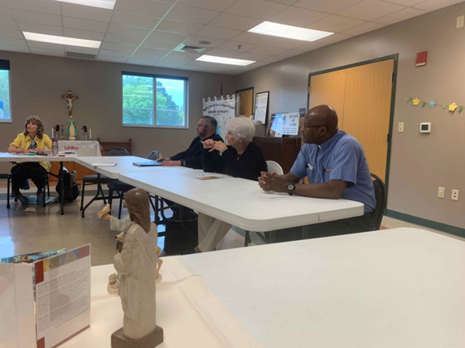

Here is Msgr. Michael Reed the pastor and Fr. Christian Plancher SMM/PhD also part of the parish of St. Rose of Lima. The secretary, Louise, is in the corner and Mary, an affiliate is in the center of the two priests.

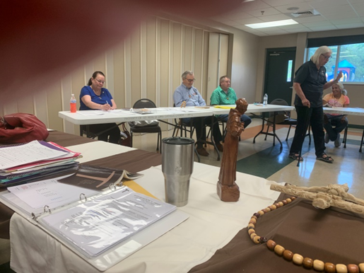

This is the minister, Shelly, who organized the meeting, and invited the four priest to come. The center person is Joseph, the soon to be, transfer person, and Leo the other affiliate that hopes to start profession.