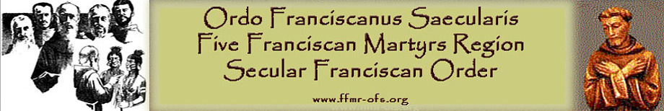

Fraternal Visitation Report

St. Anthony of Padua, Boynton Beach

June 16, 2024

Jeane Swaynos, OFS

FFMR Regional Minister

**Present**: Jeane Swaynos, OFS FFMR Regional Minister

**Council**

* Jane Rader OFS – Minister
* Carol Knight OFS – Vice Minister
* Sylvia Chai OFS – Formation
* Gilda Galdo OFS – Secretary (absent)
* MariAnn Hannon OFS – Treasurer
* Ana Kenefick OFS – Councilor (absent)

Spiritual Assistant

* Father Richard Florek, OFM Conv

Members

* Marie Guzman OFS
* Margaret Davis OFS
* Eleanore Lindelof OFS
* Rita Napolitano OFS
* Dora Avallone (inquirer)
* Frank Avallone (inquirer)
* Martino De Boise OFS
* Sandy Myron OFS
* Gianilda Heagy (candidate)
* Frank Laverty (visitor)
* Sue Ann Miller OFS
* Dan Ferron (candidate) (absent)

There are 12 active members 2 candidates 2 inquirers, 4 excused active, 2 permanent visitors

**DOCUMENTATION**

The preliminary paper work was complete and done on time. The minister’s binders, secretary’s binder and the treasurer checkbook and bank statements were all in order. The register was signed and the original charter was on display. They are a well-organized fraternity and all are part of it.

**FORMATION**

*INITIAL*

They presently use the FUN manual along with Journey for initial formation. There are presently two people in formation and two inquirers. They use “The Franciscan Journey” and also the FUN manual as a resource. There are three people that help with formation and one backup person. Carol Knight meets with post-formation individuals immediately following our fraternity gathering at the same time as initial formation.

*ONGOING*

The fraternity uses the formal book “Franciscan Journey” for ongoing formation. The members are involved as moderators for the discussions. The Spiritual Assistant, Fr. Richard Florek, OFM Conv. attends the council meetings and the fraternity meetings. He provides additional Franciscan spiritual items for reflection.

**APOSTALIC WORK**

* The fraternity participates in manning the Divine Mercy booth and handing out fraternity flyers at the South Florida Fair.
* With permission from their pastors, fraternity members from different parishes place fraternity trifold brochures in the parish churches
* The members of the fraternity write to Seminarians and men in formation: They want to create camaraderie with the local seminary, St. Vincent de Paul Regional Seminary, to spread the word about the Franciscan community and life. They do this by writing individual letters to the seminarians and by sending them a bimonthly newsletter, specifically created for each mailing. They hope to encourage seminarians to inquire about the OFS. All members participate in this apostolate.
* Several members of the fraternity mak rosaries to be distributed at Jupiter Medical Center, a local hospital
* The fraternity helps the needy in our area by bringing nonperishable food donations to St. Mark’s Church each month before group Mass. All participate
* The fraternity collects items for Birthline/Lifeline, a pregnancy care center in Boynton Beach. All participate
* There is one member that is activing tutoring 4th grade children. The visitor suggests she include others in this. They will need to be fingerprinted first.

Prayer life

* They attend funerals and pray for the deceased members of the fraternity and their family members. Many members attend funerals in their parishes and pray for the deceased even it they do not know them
* The fraternity arranges for a Transitus prayer service, inviting all parishioners and seminarians to the service, followed by refreshments
* The begin their meeting with 10:30 mass that they attend as a group
* They pray the liturgy of the hours. This was the suggestion given at the last visitation in 2021.

**Summary**

This is a vibrant, active fraternity. I witness a joy within the members, a very warm welcome, and a strong desire to be together. They are kind and giving to each other. This is why it was suggested that they reach out more deeply to the brothers and sisters that may not attend the meetings. Whenever the fraternity has a mini retreat, special Mass, on the Feast of St. Anthony, St. Francis, Our Lady of the Angels, funeral for a member, Profession and Transitus prayer service, they arrange to have it live-streamed so that the absent members (as well as those who have moved out of state) can connect with them. They also have members who reach out and call/email and visit homebound or hospitalized members. It is well organized and many share the responsibilities.

They have a good relationship with their church and many belong to other parishes. They see the balance between parish ministry and the Franciscan fraternity. Continue to give out the brochures in the various parishes. There are two candidates and two inquirers, soon to be candidates. They work well together and all take part in the life of the fraternity. They share the responsibility or formation, both ongoing and initial. The first part of the meeting the members shared their stories. We talked about their apostolic work and how it was important that they came in direct contact with the poor. We discussed that since they are a close family, they should be reaching out to the members that could no longer attend. Some it was health reasons and others because they were now the caretakers of others. After talking to them individually, I suggested that they include in their apostates helping the members that are not able to come to meetings. They are a family and having weekly contact with their previous members that are temporarily inactive.

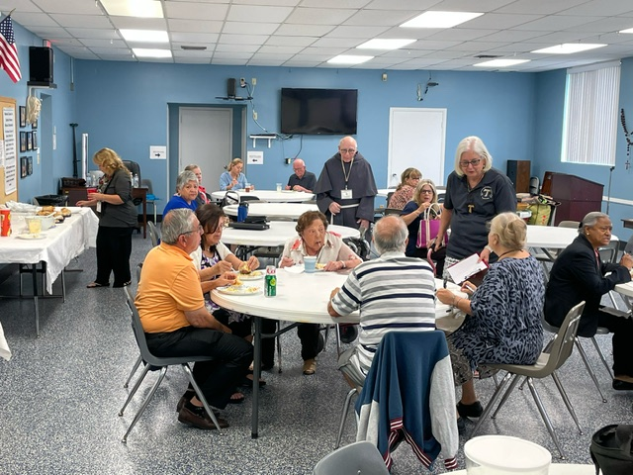

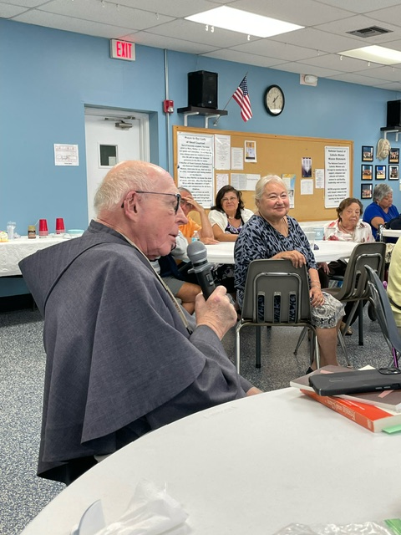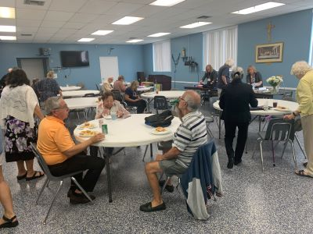

Father Richard Florek, OFM, Cap, the Spiritual Assistant to St. Anthony of Padua, Boynton Beach

St. Anthony of Padua, Boynton Beach, visitation on 6-16-2024

St. Anthony of Padua, Boynton Beach is great at preparing food. The visitation on Father’s Day was warm and welcoming.

Here are some of the members at the start of the gathering. The cake did not last long. This is only part of the display of food.

