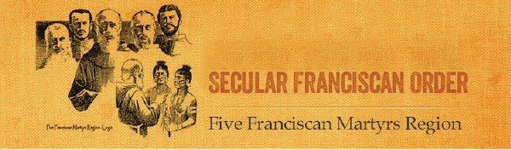
REGIONAL EXECUTIVE COUNCIL
The Joyful Messenger
Winter 2024

Jeane Swaynos, OFS
Regional Minister
Sheila Solomon, OFS
Regional Vice Minister
Janice Novello, PhD, OFS
Regional Formation Director
Karen Rooney, OFS
Regional Treasurer
Marcia Stamboulian, OFS
Regional Secretary
Brother Lombardo D’Auria, OFM Cap.
Regional Spiritual Assistant

REGIONAL FAMILY COUNCILORS
Hilda Aguilera, OFS Rachel Ahern, OFS Mark Banschbach, OFS Larry Bleau, OFS
Patti DeWitt, OFS Awilda Guadalupe, OFS Kelly Otero, OFS
Margie Sweeney, MD OFS

STANDING APPOINTMENTS

Mark Banschbach, OFS
Webmaster
Theresa A. Zesiewicz, OFS
Electronic Newsletter Editor
Hilda Aguilera, OFS
Multi-Cultural Liasion

Janice Novello, PhD OFS Youth and Young Adult Apostolate (YouFra)

MISSION STATEMENT
The mission of the Five Franciscan Martyrs Region of the Secular Franciscan Order is to walk in the spirit of St. Francis of Assisi by bringing the gospel to life and life to the gospel and promoting a sanctified family life.

Message from Jeane Swaynos, OFS
FFMR Regional Minister

Our Annual Reports are due February 14th. If this is an issue for you, please let your family councilor know and we will help you through this.

May 17, 18, 19 Annual Chapter Meeting at San Pedro Registrations will be sent to the Ministers in the middle of March

This will be a retreat year and our speaker will be Father Nicholas Mormando, OFM Cap, a Capuchin Friar from the Province of the Sacred Stigmata of St. Francis. Father Nick comes highly recommended and we are excited that he is coming!

We are in the process of reviewing the fraternity guidelines to make them more detailed for you. We are excited about what we have done thus far. We will send them to you in April so you can preview them ahead of time before voting on them in May.

We are trying to schedule our visitations and elections, and apologize for the delay. Several of our board members have experienced health issues, and some needed to take a leave of absence. We are back together again, so thank you for your patience.

The issues that many fraternities have shared are the following:

- No Spiritual Assistant available
- Decrease in members due to health and increased family responsibilities
- Lack of new members coming to fraternity meetings
- Not enough members to take over leadership positions

Here is the number of members for the fraternities in our Region. This will give you an idea of where yours falls.

  - 0-10: 6 fraternities
  - 10-20: 15 fraternities
  - 20-30: 6 fraternities
  - 30+: 3 fraternities

There are 14 fraternities without Spiritual Assistants.

Here are some ideas for apostolates that may work in your fraternity

  - Make dinner for your Youth Group at your parish
  - Make prayer shawls for the sick and infirmed in your parish
  - Make bags for the homeless with small food items ready to eat.
  - Dedicate a Sunday in the local parish to collect particular items for the homeless

    - Underwear NEW (men prefer boxer shorts and need small sizes)
    - Backpacks
    - Socks
    - Deodorant
    - Bug spray and sun screen
    - Belts and hats

  - If your parish has Bible School have an ice cream social for the children
  - Have a Peace Award for a Catholic School in your area
  - Make prayer cards and personal notes for nursing home patients
  - If you are presently involved in an apostolate work, take a member of the fraternity with you.
  - Deliver “Meals on Wheels” with another Franciscan.

Now let’s focus on the positive!

  - Mother of the Living Gospel, our newly established fraternity, has 8 members in formation
  - There are retreats and ceremonies going on throughout the Region that all are invited to. Please see the Regional Calendar on the website. You can also access this on your phone.
  - There are ZOOM monthly formation classes taking place, organized by our formation councilor, Janice Novello, OFS
  - We now have over 50 candidates in formation throughout the Region

- On December 17th, 2023, we celebrated one of the Franciscan Centenaries,“The Greccio” at the Basilica Mary Queen of the Universe in Orlando. Lady Poverty Fraternity in Winter
Park organized this event with the Basilica. Over 50 people from around the country attended. This will be a yearly event.
- You have voted for a team of 14 people who have dedicated themselves to St. Francis as a lifetime profession and are willing and able to work for you and help you grow.
- The Holy Spirit is on our side.

When we make our visitations, there are many positive things we see. If you or your fraternity are having difficulties and are in a slump, contact other fraternities and participate in some of their activities. We see fraternities close to deactivation come forward and get involved with activities, and rise to new life. St. Joseph’s in Fort Lauderdale is one such family. Reach out to your family councilor and the regional team.
We will help you as best we can.

Family Meeting Dates

Family of St. Elizabeth of Hungary (Central and Northeast)

Family Meeting Date: 6-29-2024

Pattie DeWitt (Minister of St. Francis in Apopka)
- Little Flock Fairhope, Alabama
- St. Anthony of Padua, Milton
- St. Joseph, Cocoa Beach
- Our Lady of the Angels, Melbourne
Margie Sweeney (Minister of Mother of the Living Gospel and SA for St. Francis in Apopka)
- Queen of Peace, Ocala
- San Damiano, Summerfield
- St. Francis of Assisi,Clearwater (St. Thomas More Family)

Larry Bleau (Member of San Damiano in Summerfield)
- St. Bonaventure, Fleming Island
- Mother of the Living Gospel, Orlando
- St. John Capistrano, Tampa (St. Thomas More Family)
- St. Maximilian Kolbe, Debary

Kelly Otero (Minister of Maximilian Kolbe in Debary)
  - Our Lady of Guadalupe, Tallahassee
  - Nombre de Dios, Palm Coast
  - Little Flowers, Daytona Beach
  - Lady Poverty ,Winter Park

Willie Guadalupe (Member of San Damiano in Summerfield, SA for Mother of the Living Gospel and SA for Queen of Peace in Ocala)
- Espejo de Cristo, Hialeah (St. Margaret of Cortona Family)
- St. Francis of Assisi, Apopka
- El Encuentro, Winter Haven

Family of St. Margaret of Cortona (South)

Family Meeting Date: to be determined

Hilda Aguilera (Member of Espejo de Cristo in Miami)
  - St. Joseph, Ft. Lauderdale
  - St. Elizabeth of Hungary, Port St. Lucie
  - St. Padre Pio, Jensen Beach
  - Divine Mercy, Vero Beach
  - St. Anthony of Padua, Boynton Beach

Family of St. Thomas More (West Coast)

Family Meeting Date: 4-27-2024

Mark Banschbach (Member of St. John Capistrano and SA for The Encounter)
Rachel Ahern (Minister for St. Francis of Assisi in Clearwater)

- Bl. Solanus Casey, Venice
- St. Clare of Assisi, Port Charlotte
- St. Maximilian Kolbe, Cape Coral
- St. Clare of Assisi, Ave Maria
5. St. Anthony of Padua, Gulfport
6. San Damiano, Ruskin
7. St. Michael the Archangel, Tampa
8. Portiuncula, Sarasota

What is Mercy?
by Jeane Swaynos, OFS

FFMR Regional Minister

I’ve seen so many references to Mercy this year. I have always been a little bit confused by this emotion. I very rarely use it in a sentence like compassion or forgiveness, since its meaning is a little fuzzy. What is it? Is it an emotion? Brene Brown in her Atlas of the Heart does not list mercy as one of the 87 primary emotions that define what it means to be human. Forgiveness, compassion and mercy are typically defined as virtues that represent moral demands that are not satisfied by actions alone, but require certain motives or dispositions of character. This is my attempt as a Secular Franciscan to explain mercy and how it differs from compassion and forgiveness.

Many definitions come to mind so my first resource was the dictionary.

Mercy as a Noun: “Compassion or forgiveness is shown toward someone with whom it is within one’s power to punish or harm them”.
Mercy as an exclamation: Used to express surprise or fear: “Mercy me!”
Mercy in the Bible: Forgiveness or withholding punishment
This is what Jesus says about Mercy. “I desire mercy, not sacrifice. For I have not come to call the righteous but sinners”.

Is there a difference between compassion and mercy?
Compassion can be defined as pity or concern. Hence, being compassionate is when an individual shows concern or pity towards another. Mercy, on the other hand, can be defined as forgiveness shown toward someone. Being merciful is when an individual shows mercy or relieves another from suffering.

Is Mercy an emotion?
Affective mercy is an emotion. It is the pity we feel for the plight of another. In this respect, St Thomas
says, human mercy is grounded in a “defect” in our nature; the defect of human vulnerability to suffering. We feel pity for those who suffer because, we too, are subject to such misery. Mercy derives from the Old Latin word, “merces”, meaning “wages,” “fee,” or “price.”

What is the difference between Mercy and Grace?
Mercy is the act of withholding deserved punishment, while grace is the act of endowing unmerited favor. In His mercy, God does not give us the punishment we deserve. While in his grace, God gives us the gift we do not deserve, namely heaven. Mercy and grace are the utmost attributes of love.

What is the difference between Mercy and Forgiveness?

Forgiveness involves overcoming anger and resentment, and mercy involves withholding harsh punishment that one has a right to inflict. While mercy concerns how you act toward the wrongdoer, forgiveness centrally concerns how you feel about someone. Both allow for healing.

The major difference is that being merciful involves being compassionate and forgiving when someone does not deserve it. Before we can recognize a merciful God, we have to have a view of our weaknesses
and why we need mercy. We ask ourselves, “What did I do wrong? I go to church, financially support it, and pray every day. I am a good person”. We are blinded to our need for mercy. To find the mercy of God we need to have a grasp of how to examine our conscience. If we do not first acknowledge our sins, we will not recognize His mercy. We cannot see the need for mercy until we first recognize how we have strayed away from God. Repentance and acceptance of mercy require an admission of guilt for committing a wrong, or for omitting to do the right thing; a promise to resolve not to repeat the offense. If Pope Francis can recognize his need for mercy and has dedicated a year to it, then there is something I am not seeing.

The one who gives mercy also has the power to withhold it. Can our marginal population with no power give mercy? They can forgive, but how can they give mercy without power? How do we as Franciscans, who hold a special place with our marginal population, show mercy? We begin by finding our weaknesses
and as this becomes clearer, our hunger for mercy will take root. There is no time limit. “His mercy endures forever”

Formation.

By Dr. Janice Mary Novello, OFS FFMR Formation Director

When going through Initial Formation, there was so much to learn, so many new topics to explore, and lots of work to incorporate the Gospel into my life in new ways. The Rule was discussed, but it unfortunately became one more item to learn about, not one to delve into in depth and consideration.

After being trained using the F.U.N. (For Up to Now) Manual and the coordinated use of The Franciscan Journey, I joined our Fraternity Formation Team. Going through the sessions with our new Candidates, I began to see the beauty of the Rule. Not a list of “You must”, but as an outline for becoming one with God and my brothers and sisters. What a Joy!

Sometimes, there may be a feeling that once one has Professed, the need to review The Rule is not a priority. It is in the background framing our actions and decisions, but not really examined. Yet, as one lives the “Gospel to Life, Life to Gospel”, the Rule becomes more important and its guidance becomes more relevant.

Our National Formation Team sends out weekly information on The Rule, sharing commentary on each article. A suggestion for fraternities is to set aside time in Ongoing Formation to study each article and to read the commentary written about it. Ponder it, discuss it in small groups, and consider how that article might be used to bring the Gospel more fully into our lives.

Some resources you might use are the opening comments in most chapters of "The Franciscan Journey", especially Chapter 11 on the Secular Franciscan Rule in the FUN Manual (46 pages).

It is a joy to share that a small book has been published to help us study the Rule and its application. Fraternities might wish to purchase a copy for each member and then slowly, article by article, make a meaningful study and allow time for each member to develop an Action that will assist in daily life. This book is available through the NAFRA Website. For more information, please contact Claudia at claudiakauz.sfo@gmail.com.

Youth and Young Adult Commission (YouFra) Janice Novello, OFS, Commissioner

FFMR Youth/Young Adult Animator NAFRA YouFra Commissioner

During an interview for a local newspaper, the reporter shared with me that many churches modernizing and working to be more relevant to today’s young adults are not doing well with attendance. “Why,” she wanted to know, “is your Church, which is very traditional in its services, doing so well?” Our Parish had just added its seventh Sunday mass (two on Saturday), yet there was standing room only in our huge church. Six weekday masses were full, and Adoration was extended several more hours daily.
Forty-seven lay ministers—some leading more than one ministry—were engaged throughout the week, and a capital campaign to build an additional building to accommodate meetings and classes was begun.
Approximately 40 new families each month registered for envelopes. Yes, our Parish was doing well.

To me, the answer was simple. All of our activities are based on the 2,000-year-old teachings of the Bible. Our Liturgies always led to worship that kept the Sacrifice of the Mass and the Eucharist in the forefront. Everything, from appropriate music to simple flowers, set the environment for the dignity of worship.
Everyone is welcomed as family, whether they have been regular parishioners for twenty-five years or just stopped in for the first time. There was always a meaningful place for everyone regardless of age and talents.

The results of survey after survey clearly indicate that young people do not want liturgy, or Catholicism, watered down. They are not looking for “pretty.” They do not want to be exceptions. They want to learn about Catholic Social Teachings and be given the opportunity to practice their Faith outside of Sunday Mass. They want to form Communities of Faith with their peers in their Parish and celebrate the joys of being young, while living for God.

As you plan activities for YouFra, remember the words of a young man who was quoted by the USCCB:

Young adults hunger and thirst for God. We desire to experience Christ's love in our own lives so that we may live lives of hope. As we develop our spiritual life, we look for three things. First, we search out meaningful experiences of liturgy. Second, we seek to learn more about our faith. Third, we are eager to share our personal stories in a small Christian community of friends...
--Sergio Rodgrigues, Providence, R.I.

DEEP, DEEP IN THE CAVE

Francis I come today Just so I can pray.
I feel so alone
My sorrow is deep in my bones. As I came in
I saw that you were in deep meditation! Adoring the child
But I am running wild
How can I just stop and be still? To follow our Father’s will.
Dear sister just come and see What He has done for you and me He took on flesh
So we could start afresh. But Francis
I insist.
Teach me to come into the light I beg you with all of my might. Just live day by day
Is all I can say.
Don’t ever leave Him out of your sight Remember He is the Eternal Light.
Will He guide me out of this dark hole? Yes, He will and finally make you whole. Thank you Francis
Can you, Francis, teach me why I exist? You exist for the glory of God
He created you, so just give Him laud. Amen, 12-19-23

Jeannette Grant, OFS

NEWS FROM THE FRATERNITIES

Our Lady of Guadalupe Fraternity, Tallahassee

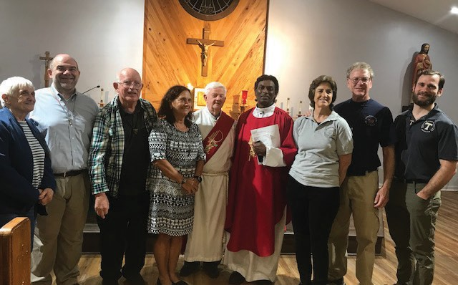

Our Lady of Guadalupe Fraternity celebrated Ann Megargee’s admission to candidacy on October 21, and Suzy Oligmueller’s and Amy Buchleitner's Profession to the gospel life on November 22. (L to R) Ann Megargee, J. Frank Pate OFS (minister), Claude Kenneson OFS (vice-minister), Suzy Oligmueller OFS, Deacon David Harris and Fr. Paul Raj Joseph HGN, Amy Buchleitner OFS, and Christopher Constantino OFS (Formation Director).

Blessed Solanus Casey Fraternity, Venice

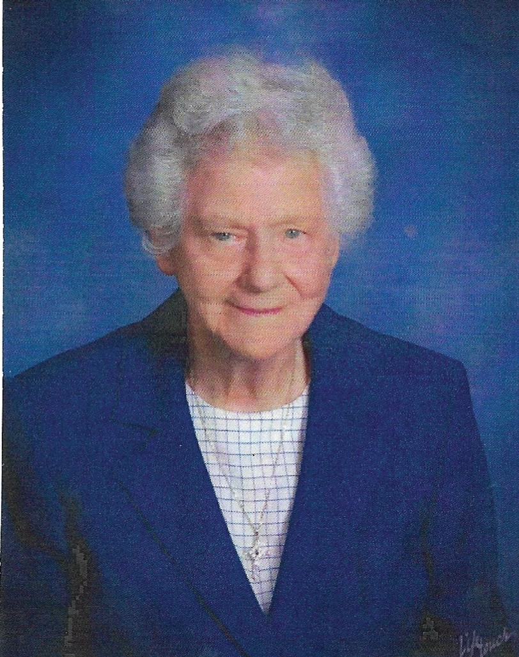
Marie Rasch
June 5, 1927 - November 4, 2023
Professed May 21, 1978
Member of Blessed Solanus Casey Fraternity Venice, Florida

On November 4, 2023 our dear sister, Marie Rasch, died at age of 96 years. Marie was active in our fraternity, serving as Councilor, until her death. She was not only the Formation Director for many of our members, but was also a mentor and inspiration to all. When asked about how she managed life for all her years she said it was “Attitude”. Her niece, Janet Brandon, who is also a professed Secular Franciscan, said that Marie was determined to bring every soul she could closer to the Father, Jesus, Holy Spirit and Blessed Mother. If you met Marie you would realize that she was a true follower of St. Francis. Not only did she believe in words “ From Gospel to Life” but also “Preach the gospel at all times. When necessary use words”. Marie earned her eternal reward. May she rest in peace!

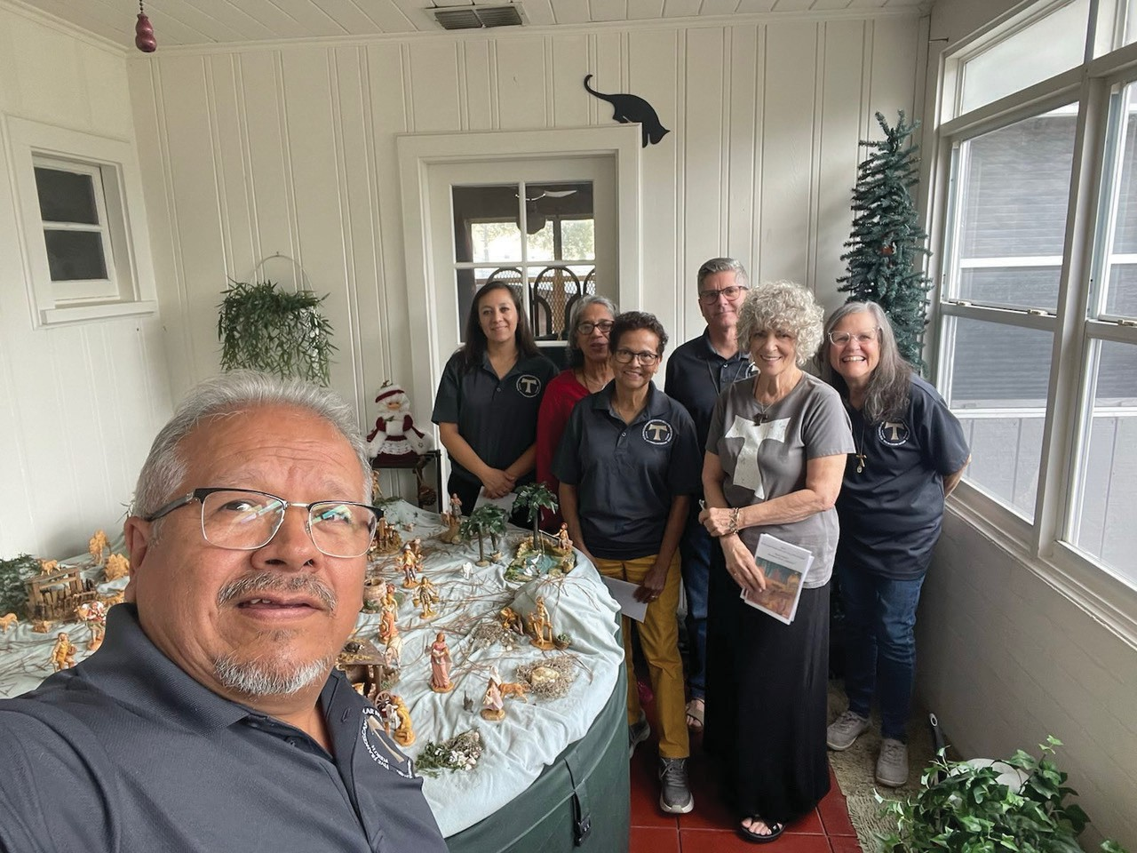
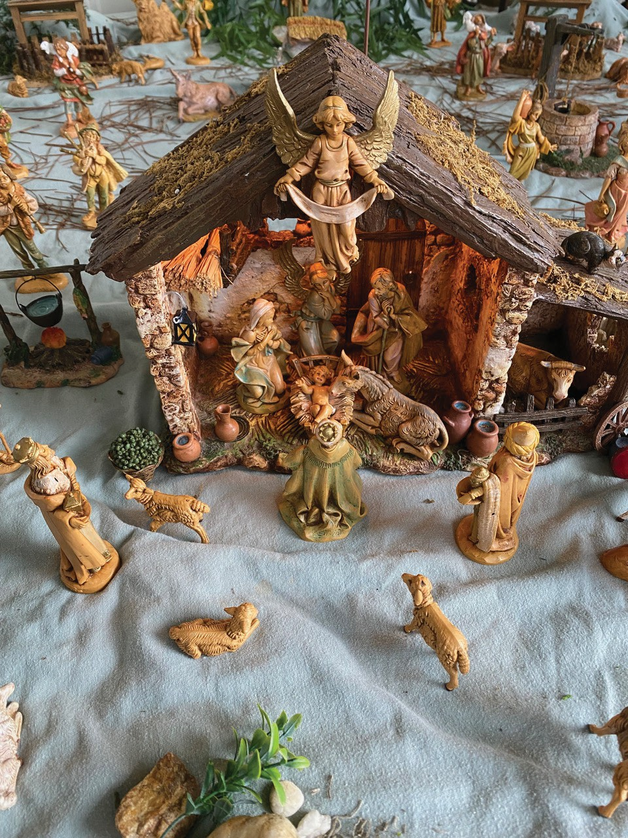
Mother of the Living Gospel Fraternity, Orlando

Mother of the Living Gospel celebrated Greccio in December at Pat Rochette’s home. She is one of our Franciscan members. Here are some pics.
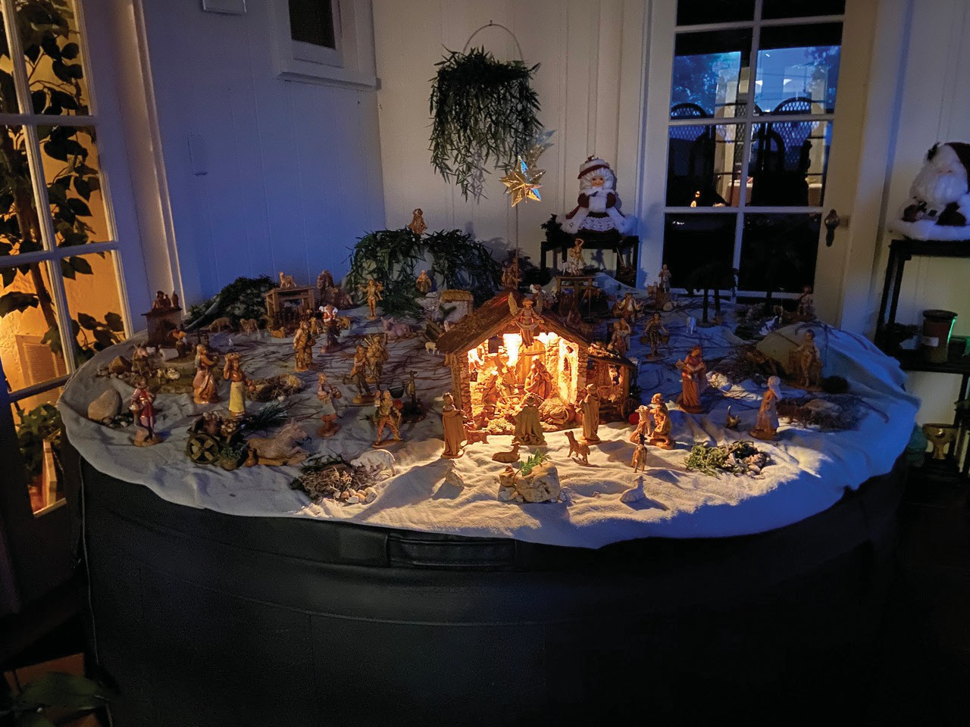
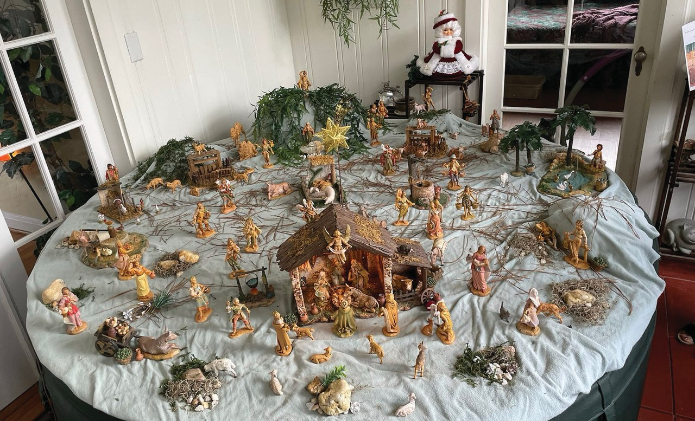
One of our members, Magdy Pavletic, OFS had a large Nativity scene in her home and she provided a video to share with all at https://www.youtube.com/watch?v=nEiPE6ftZZE&t=2s.

St. Michael the Archangel Fraternity, Tampa, Florida

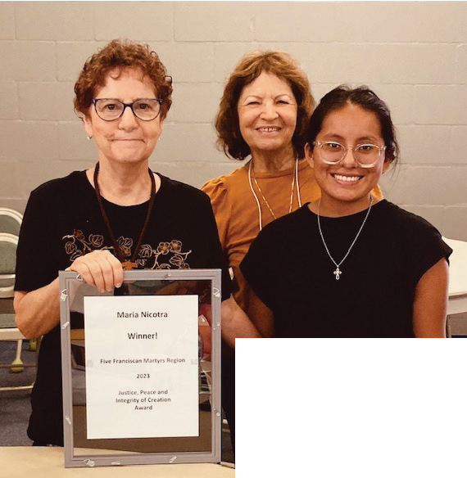
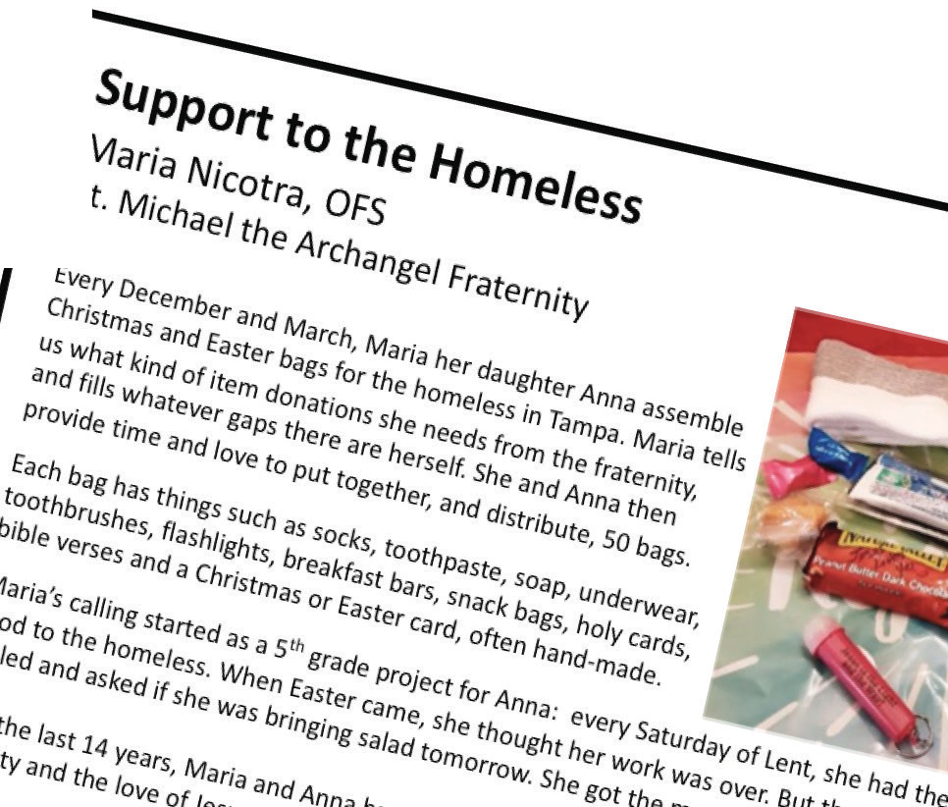
At our June Gathering, our Minister for the Saint Michael the Archangel Fraternity, Sandi Scionti, OFS, presented our own Maria Nicotra, OFS, with the Five Franciscan Martyrs Region Justice, Peace and Integrity of Creation (JPIC) Award for 2023!

Participating in the presentation was Anna Nicotra, Maria’s daughter, who each year assists
Maria in assembling and distributing the
Christmas bags for the
homeless.

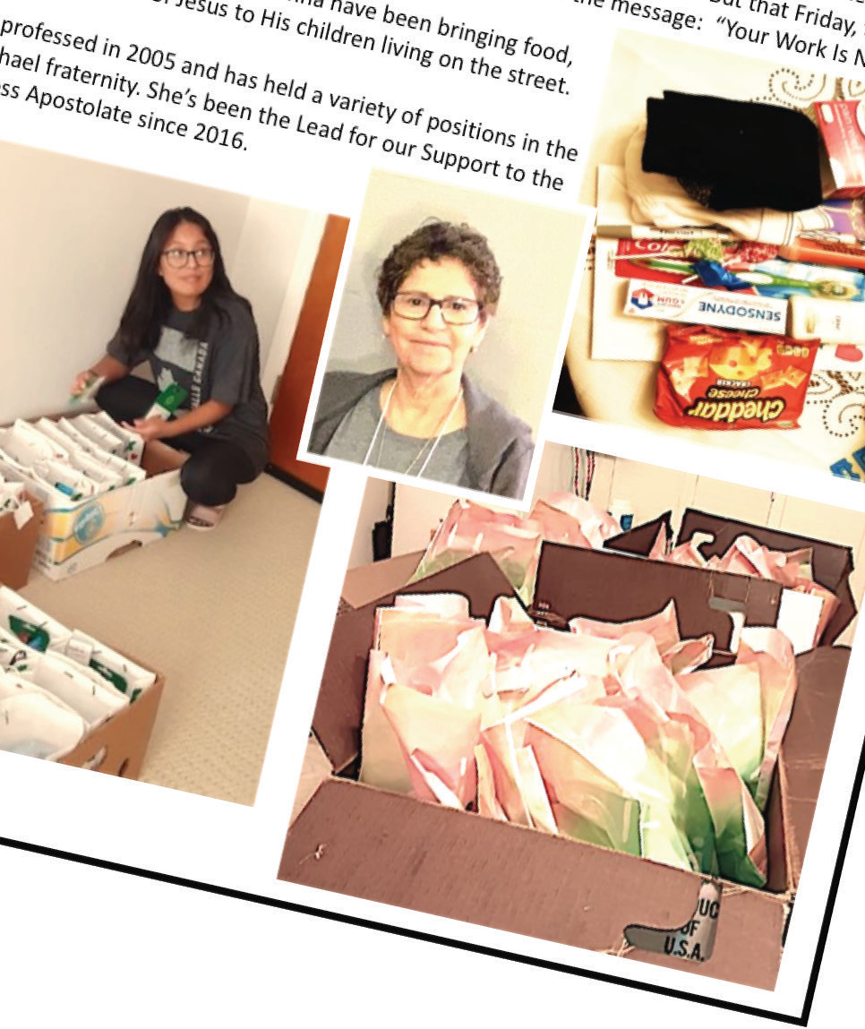

Newest Fraternity Member!

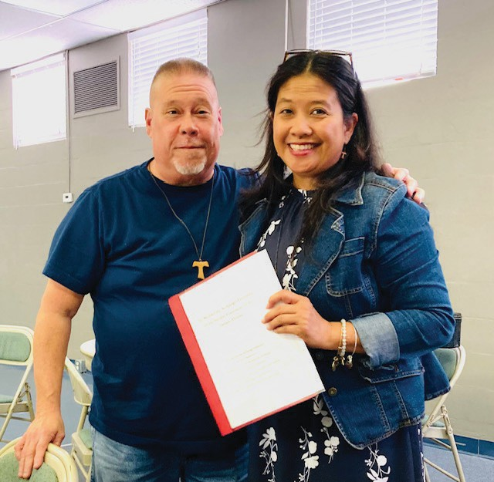
At our June Gathering, our Formation Director, James Taylor, OFS, represented the St. Michael the Archangel Fraternity in welcoming our newest member, Marigelle Malapira!

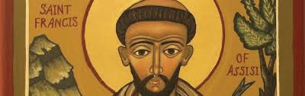
Marigelle is a transfer from the St. Clare Fraternity in Phoenix, Arizona. They admitted her into Candidacy last year and she will be completing her Initial Formation with us.

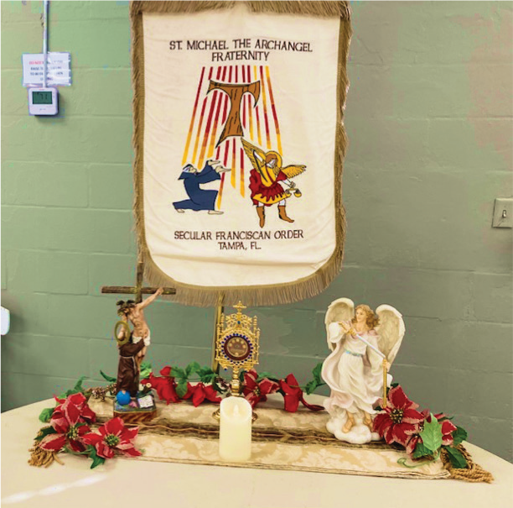
Christmas Party!
On Saturday, December 9th, the St. Michael the Archangel fraternity held their annual Christmas Gathering in the Alumni Hall of the Sacred Heart parish's North Campus.
the opening prayers and a bible reading from Isaiah on
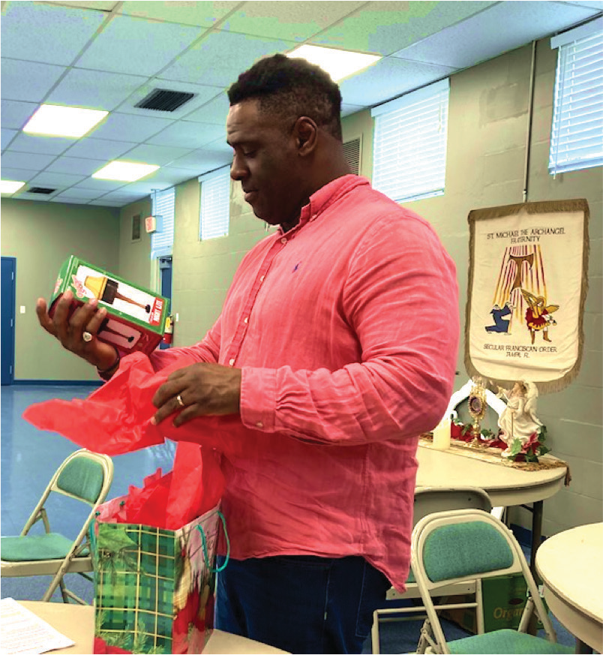
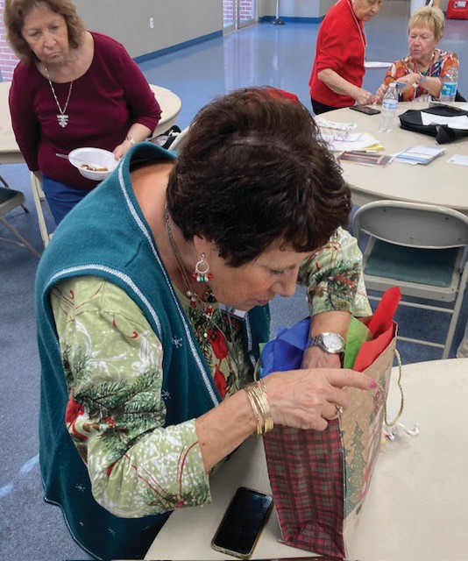
the coming of the Messiah, we all performed the Franciscan Christmas Program. We
then sat down to a pot- luck feast, followed by a rowdy White Elephant Gift Exchange.

A great time was had by all!
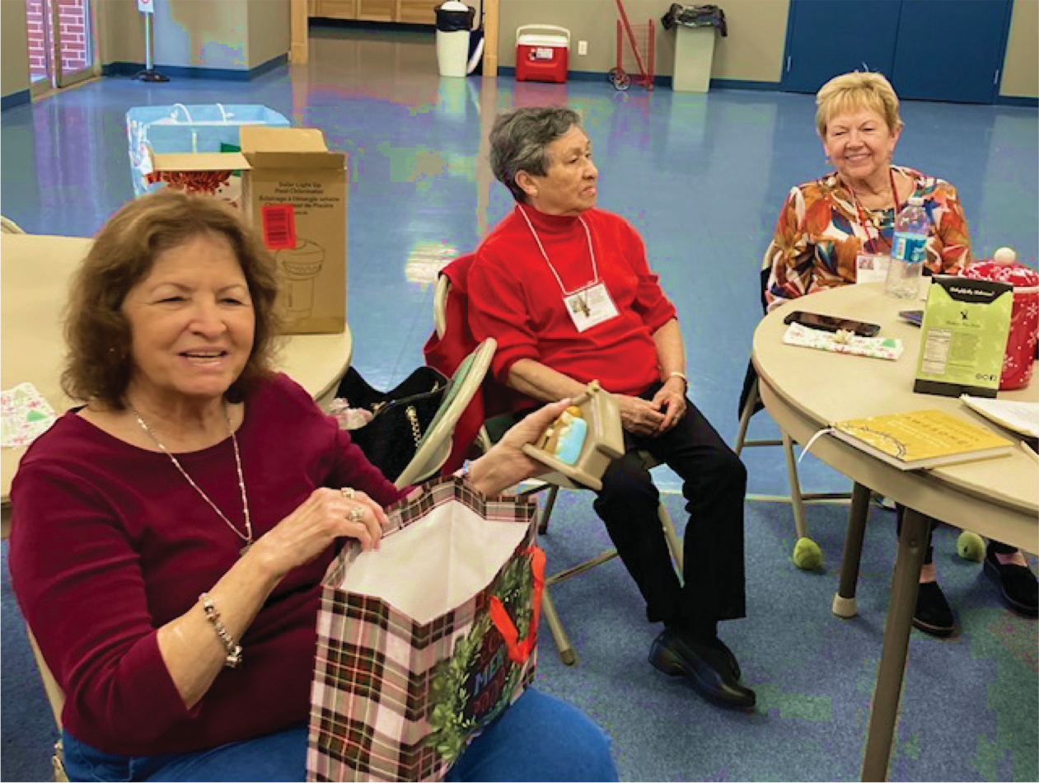
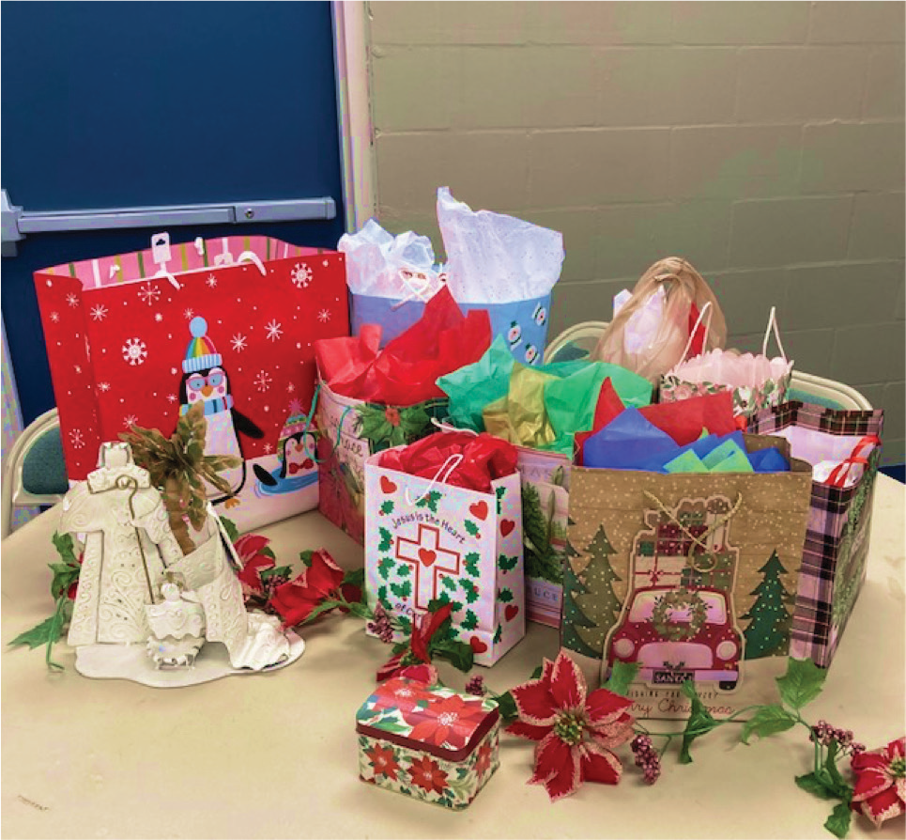

St. Clare, Ave Maria Fraternity

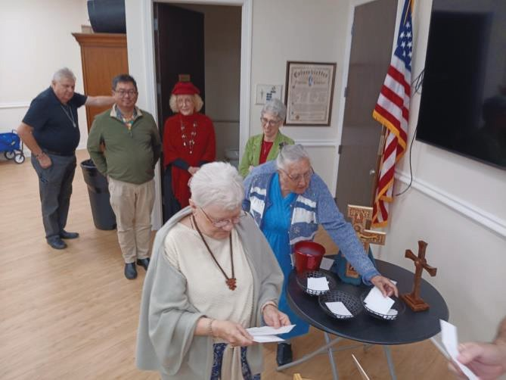
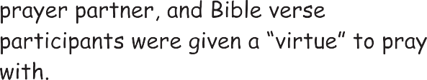

Annual Vocation Fest 2024; please visit if you are interested in a religious life, a summer job, or even missionary work. Many groups will be here to talk to you!

San Damiano Fraternity, Ruskin

Here is a collage of photos from the reception hosted by our fraternity members after the Profession of Kathy Vore, Don Vore, and Mary Ann Dunn, coinciding with our annual Epiphany Party. You can see the joy our brothers and sisters share whenever we are together!
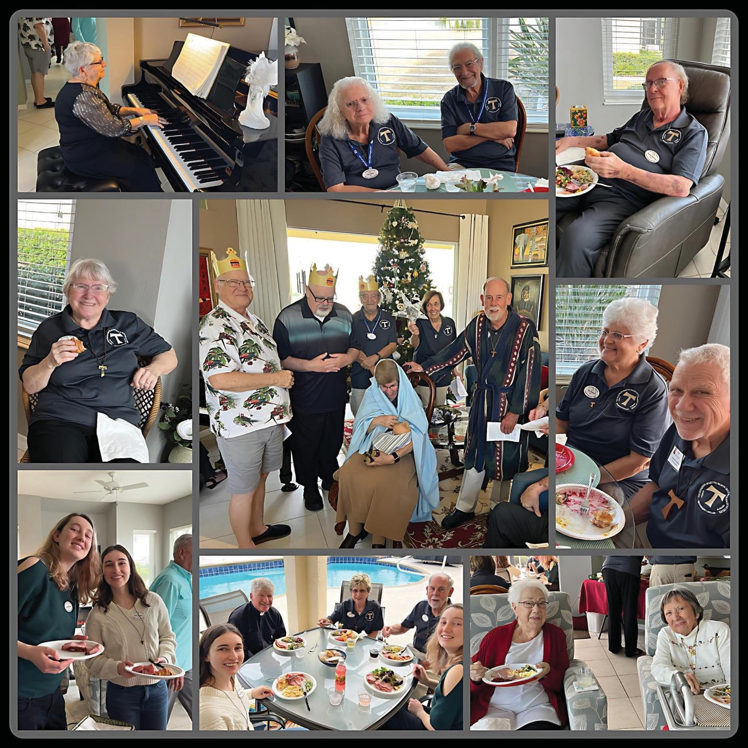

AND...
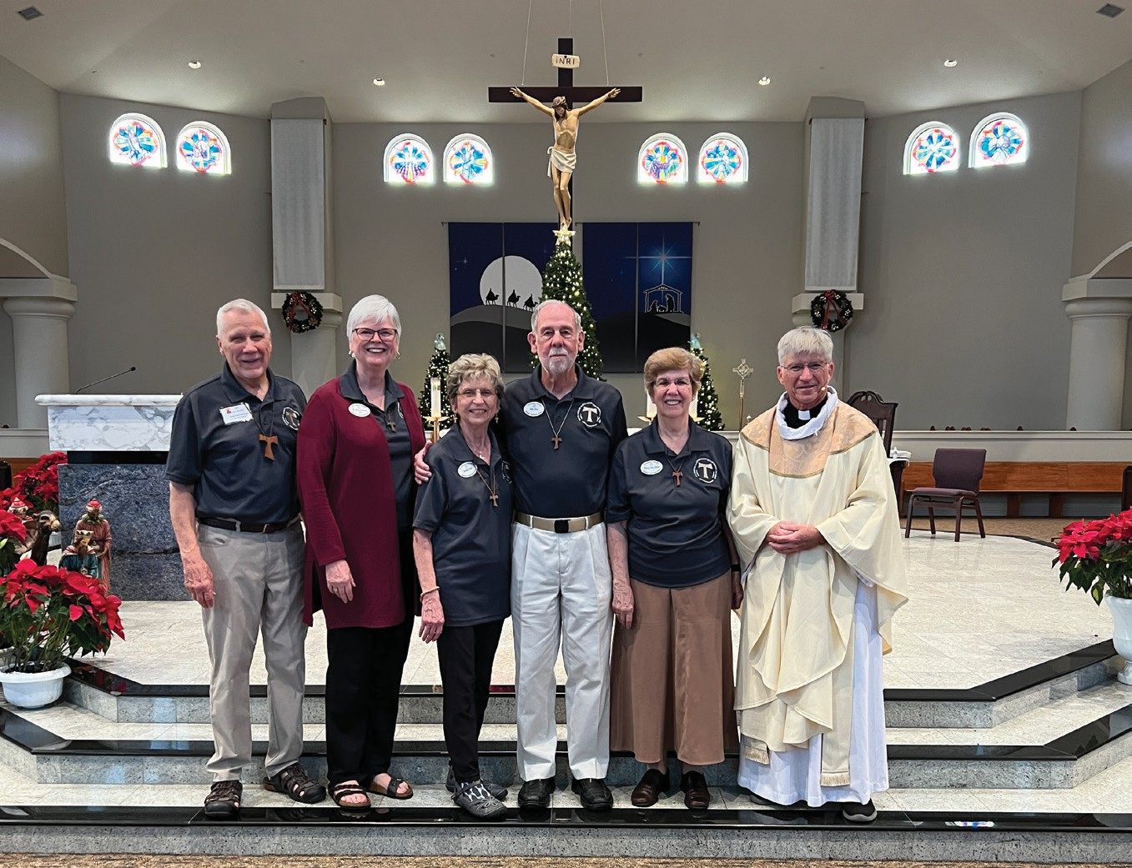
Here are a few pictures from our Profession Ceremony at 10:00 am Mass on Sat., 1/6/24 at St. Anne Catholic Church in Ruskin, FL.

Pictured are of the three members who were professed that day. From left to right:

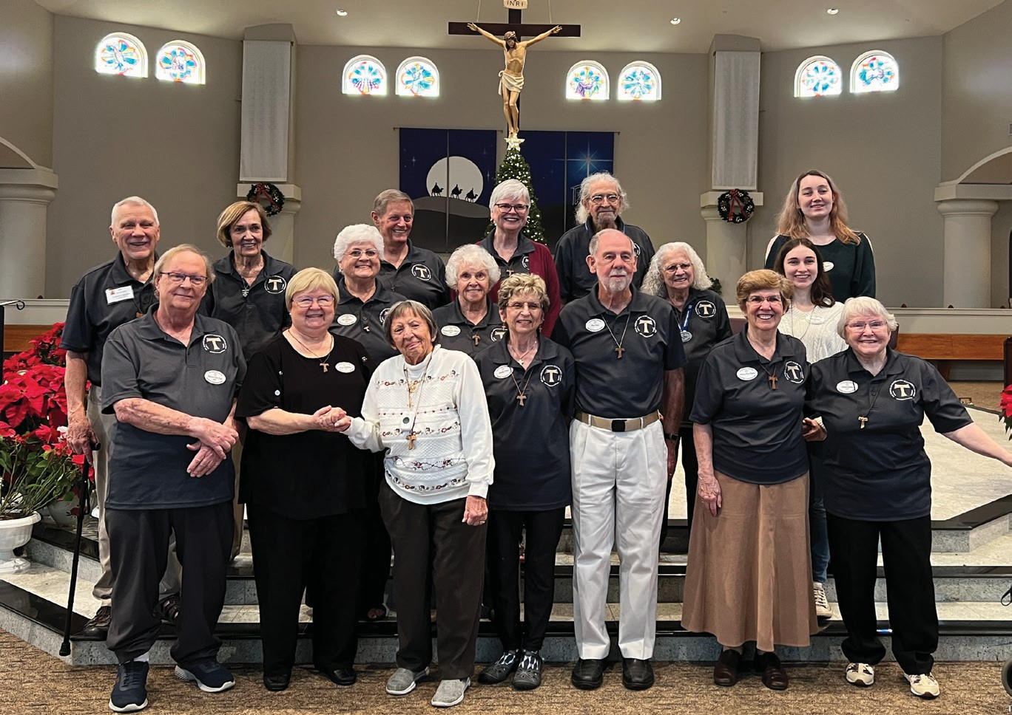
Ken Wolfert, Formation Director, Kristine Littrell, Minister, Kathy and Don Vore, newly professed, Mary Ann Dunn, newly professed, and Father Kevin, Pastor at St. Anne Catholic Church, who officiated at the Mass and Profession.

Here is also a group shot of the members of our San Damiano Fraternity of the Secular Franciscan Order. The profession of these three Franciscans after several years of preparation and study is a cause for great joy for all of our fraternity. A reception was held following the Mass, hosted by all of the members
of the fraternity.

St. Anthony of Padua Fraternity, Boynton Beach

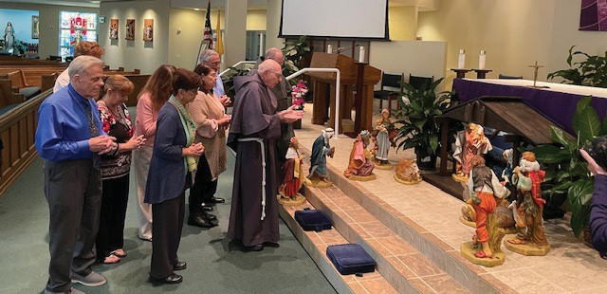

St. Anthony of Padua, Gulfport

At the Saturday morning Mass on October 21, 2023 at Most Holy Name of Jesus Church in Gulfport, the St. Anthony of Padua Fraternity solemnly and joyfully accepted the permanent Profession of our dear sister Kristen Noakes-Fry into the Secular Franciscan Order. Photos are included of Father Brian C. Fabiszewski, Pastor and our Minister, Jim Gillis OFS with Kristen during the profession, a photo of Kristen with her new Tau Hat, our fraternity after the celebration, and a photo of our newly restored St. Anthony of Padua statue.

Last year one of our fraternity members, Elena Starr, OFS found a damaged large statue of St. Anthony of Padua in a dumpster. His fingers had been broken and the paint and plaster on his body were chipped. Last summer, Betsy West, OFS, a former member of our fraternity visited us and she offered to repair and repaint St. Anthony. Our lovingly restored statue of St. Anthony of Padua stood at the altar during Kristen’s profession.

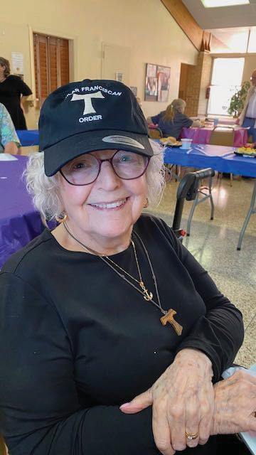
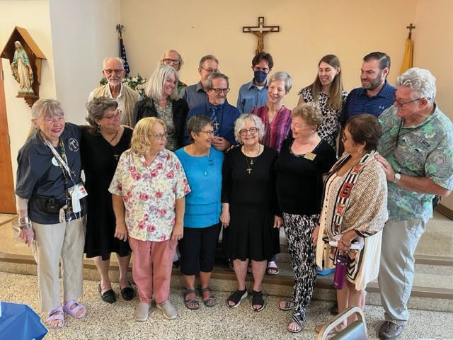
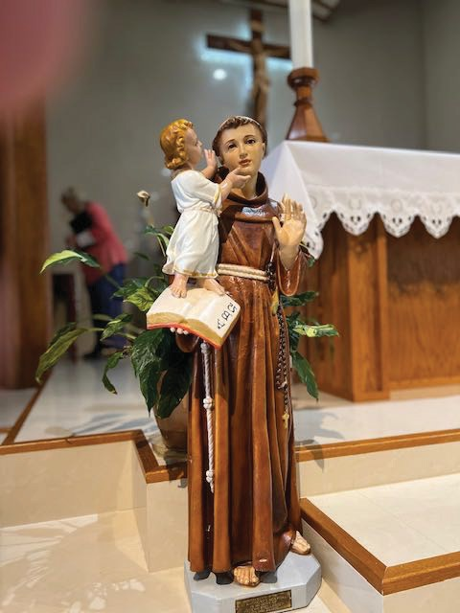
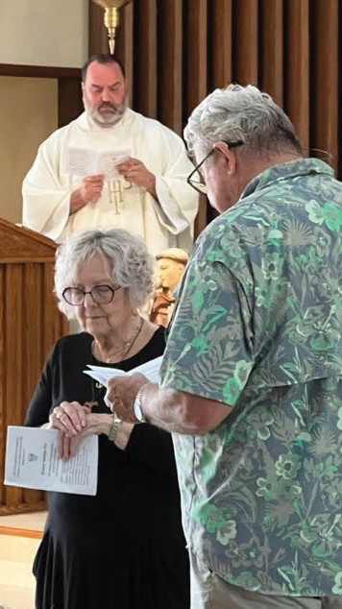

Padre Pio Fraternity, Jensen Beach

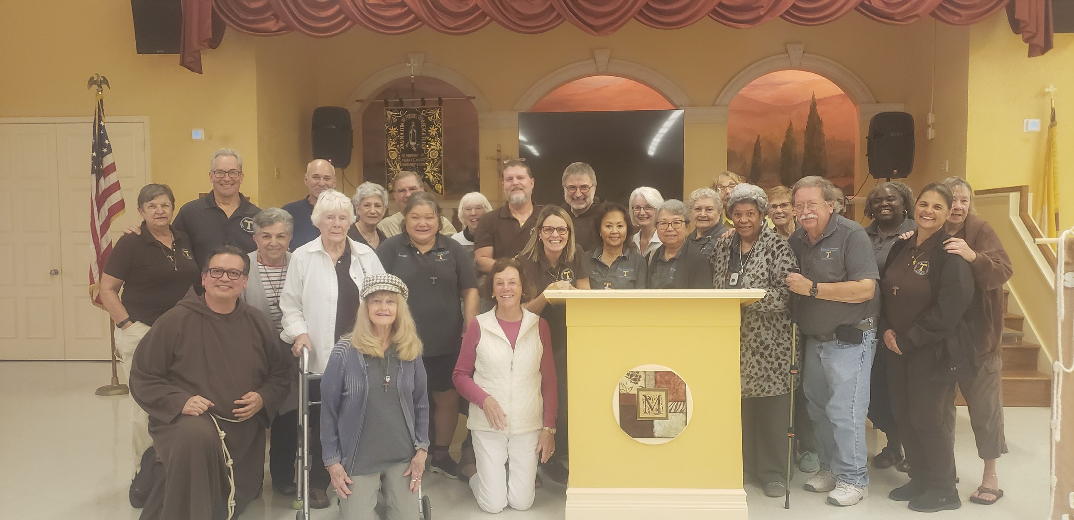
This early year is a busy one for us. On January 6th, we held a Day of Recollection with Fr. Nicholas Mormando as the speaker. There were 33 fraternity members present, not only from our Fraternity but also from 5 different Florida Fraternities, as well as from Ohio, Michigan and Wisconsin. In addition to Franciscans, there were a few other attendees as well.

