HOW TO ADD – ASSIGN VISUAL DESCRIPTOR CLOSED CAPTIONING TO MEETING :
For static, individual descriptions of each person, the only way I think this might work is to add the description in with the displayed name. I'm not sure how many characters are allowed, or whether screen readers would pick this up.

For active descriptions of things happening on screen (screen share and user camera videos), the thought I had is to use the Language Translation feature. See this Zoom Support article for details on how to set this up and use it. As part of enabling it for the user/group/account, add a "Language" something like this:
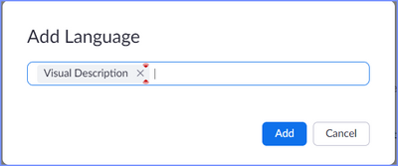
Then edit the meeting, click the Options at the bottom, then add an "interpreter" who will do the visual descriptions over audio (this is optional; you can do this inside the meeting, with nobody "pre-assigned"):
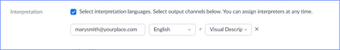
Then once in the meeting, you can assign ANYONE to the role of "visual interpreter":
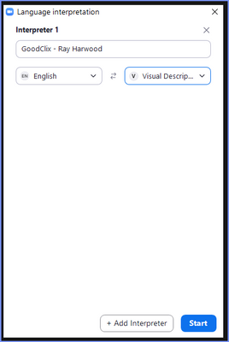
Then attendees needing the visual descriptions can select the "translation" feature:
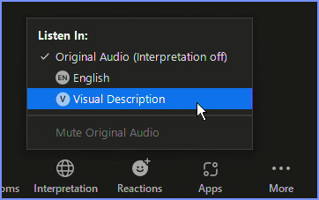
They will continue to hear the original "English" audio, but the "visual translator" can interject any time something is happening on screen that should be described.

