SECULAR FRANCISCAN

ORDER

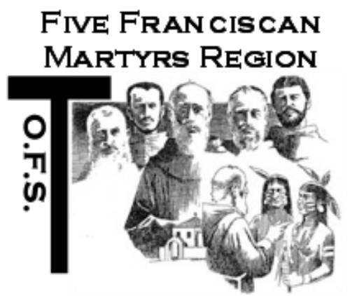

CHAPTER of ELECTIONS

and PRAYERS

For

Local Fraternities

Five Franciscan Martyrs Region

2/1/18

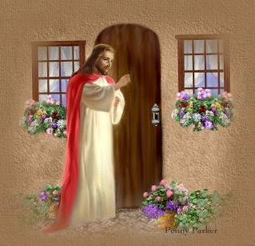
Outline Before Chapter (FFMR guidelines, Chapter 11, 52-62)

- Presider or Minister: Appoints a Secretary and two Tellers, filled by professed members (GC 76.4) invite them forward. (Small fraternity may use those in formation or observers.)
- Minister: Provides the Secretary with a voter list (“Roll-Call”), the Report of Elections form, a ballot and vote count form, and a copy of the Ritual.
- Presider: Determines if a quorum is present (more than half of all professed) and reviews all nominations in accordance with the G.C.; those nominated from the floor must be professed and present in order to accept the nomination, or alternatively a dated and signed letter from the nominee indicating willingness to run and acceptance of election, if elected. A phone call to the nominee to confirm acceptance of the nomination to determine acceptance of election is acceptable.
- Fraternity Minister: Introduces Presider and turns the Chapter over to the Presider.
- Presider: Reads any Letters of Delegation.
- Presider: Introduces the Ecclesial Witness.
- Presider: Formally recognizes members of the outgoing Executive Council and expresses appreciation for their service.
- Presider: Gives a brief explanation of the importance of this elective chapter for the life of the fraternity, for the life of the Order, noting the responsibilities of those called to servant leadership in the SFO i.e. Commitment to OFS life, prayer, collaboration, gift of time, etc.
- Presider: Announces the following order: Minister, Vice-Minister, Secretary, Treasurer, Formation Director, and Councilors-at-Large. Explains the reasons for the order.
- Presider: Reminds everyone that the election will begin with prayer after which there should be silence and no one may leave the room; note that if anyone needs to leave the room during the election they need to inform the Presider. Ask all to hold applause until the one who has been elected accepts the election and the election is confirmed by the Presider.

Celebration of the

Fraternity’s Chapter of Elections

Invocation of the Holy Spirit: May be the hymn: “Come, Holy Ghost” or prayer below:
Almighty, eternal, just and merciful God, give us the ability to act in accordance with our knowledge of your will and to desire always what pleases You. Cleanse and enlighten our hearts and enkindle in us the Holy Spirit, that we may follow in the footsteps of our Lord Jesus Christ, your beloved Son and with your grace alone, make our way to you, most High.

Ecclesial Witness: Gives a short reading from Scripture or writing of St. Francis. (See pg. 6)

Presider: Election Prayer for SFO Leadership
Give us, O God, leaders whose hearts are large enough to match the breadth of our own souls
and give us souls strong enough to follow leaders of vision and wisdom. In seeking a leader, let us seek more than our own enhancement, though enhancement we hope for -more than security for our own plans and vision - though security we need - more than satisfaction for our own selfish wants - though many things we desire.
Give us the hearts to choose and follow the leader who will work with other leaders to bring Your will to the agenda and help us to fulfill it. Give us leaders who will lead us to virtue without seeking to impose their own version of virtue on others. Give us leaders who will provide for the advancement of our order without dictating to others how to achieve it. Give us insight enough ourselves to choose as leaders those who can tell strength from power, growth from greed, leadership from dominance, and real greatness from the trappings of grandiosity. We trust You, Great God, to open our hearts to learn from those to whom You speak in different tongues and to respect the life and words of those to whom You entrusted the good of other parts of this globe.
We beg you, Great God, give us the vision as Secular Franciscans to know where holy leadership truly lies, to pursue it diligently, and to ask it to respect the integrity of every person in the entire Order.
We ask these things, Great God, with minds open to Your word and hearts that trust in Your eternal care. Amen. (Adapted by Anne Mulqueen, SFO and Fr. Kevin Queally, TOR, from “Prayer for Leadership”, Published by Pax Christi)

The Election follows:

Presider: Announces the Office of ________________ and asks if there are any other nominations from the floor and directs that that the newly nominated member’s name is added to the board. After asking three (3) times, the nominations are declared closed.

Presider: Directs a Teller to count out loud the number of blank ballots; after which they are distributed.

Presider: Directs a Teller to collect the ballots.

Teller 1: Counts the number of collected ballots out loud then begins reading and announcing out loud the name of the person on the ballot, including any abstentions.

Teller-2 & Ecclesial Witness: Places a mark by nominee’s name.

Secretary: Announces the person with the most votes, with the words that are in the SFO Ritual Book, page 42 or below:
“In the name of Christ, Amen. I announce that the newly elected ________of __________Fraternity for the next 3 years is N/N__________________.”

Presider: Confirms the election for each new councilor, as in the SFO Ritual Book, p 42 or below:
Presider: _________________Do you accept this election?
Newly Elected: Yes, I do.
Presider: In the name of the Church and the Franciscan Family, I confirm the election of N/N________ to the Office of _____ of the ______Fraternity of the Secular Franciscan Order.

All may now applaud.
The election continues until all offices are filled.
Presider: Asks for motion to destroy the ballots.
After all are elected
INSTALLATION OF OFFICERS

Spiritual Assistant: In the name of the Father, the Son and the Holy Spirit.

Presider: “Now Thank We All Our God“ or “Sing a New Song to the Lord” may be sung or recited:

Side 1: Sing a new song to the Lord,
The worker of wondrous deeds.
Side 2: The Lord made salvation known,
Revealed justice to the nations.
Side 1: The Lord made salvation known
Revealed justice to the nations.
Side 2: On that day the Lord sent mercy
And song in the night.
Side 1: This is the day the Lord has made;
Let us rejoice and be glad in it.
Side 2: Blessed is the one who comes in
The name of the Lord;
The Lord is God, and has shown upon us.
Side 1: Let the heavens rejoice and earth exult, Let the sea and all that is in it roar. Let the fields and everything in them sing for joy.
Side 1: Bring to the Lord the glory due his Name. Bring to the Lord glory and honor
Side 2: Bring to the Lord, families of nations
Side 1: Kingdoms of the earth sing to God,
Chant psalms to the Lord.
Side 2: Chant psalms to the One, who ascends to the East above the Heaven of heavens.
Side 1: Behold, God speaks with a voice of power;
Give glory to God, who governs Israel,
Whose splendor and power is on High.
Side 2: God, wonderful in the saints, The very God of Israel, Will give the people power and Might; Blessed by God!
Side 1: Glory to the Father and to the Son
And to the Holy Spirit,
Side 2: As it was in the beginning, is now and
will be forever. AMEN.

ALL: Help us to think and act in the light of
your promises.

Presider: Newly elected Councilors - Please Stand Up Front
- As the new leaders of this fraternity, what do you promise?

New Council: Together - We, the Councilors of the Fraternity of _____________, accept this responsibility and service of leadership. Before Almighty God ,We promise to live daily the Gospel life in the spirit of our holy Father, St. Francis, and to try as much as in us lies, to help you, our brothers and sisters, and all the people of God, through our service, to live the selfsame Gospel of our Lord Jesus Christ’

New Council Together: RECITES APOSTLES CREED:
- I believe in God, the Father Almighty, Creator of heaven and earth; and in Jesus Christ, His only Son, our Lord: Who was conceived by the Holy Spirit, born of the Virgin Mary; suffered under Pontius Pilate, was crucified, died and was buried. He descended into hell; the third day He rose again from the dead; He ascended into heaven, is seated at the right hand of God the Father Almighty; from thence He shall come to judge the living and the dead. I believe in the Holy Spirit, the Holy Catholic Church, the communion of Saints, the forgiveness of sins, the resurrection of the body, and life everlasting. Amen.

Presider: May the God of hope bring you such joy and peace in your faith that the power of the Holy Spirit will remove all bounds to hope. (SFO Ritual, pg 43)

ALL: Blessed be God forever.

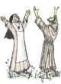
Optional Prayer After Election
- (To be said by the new council members.)
Some of this was Adapted from 2013 “Urbi et Orbi” and Divine Mercy Sunday Messages
Loving Father ~
Together we pray to walk together in mutual charity,
Ever trusting in your mercy: You always wait for us, love us.
You have pardoned us with your Blood,
And pardon us every time we go to you to ask for forgiveness.
Let us be renewed by your mercy and extend the same pardon to our brothers and sisters.
Let us accept the grace of suffering and Christ’s Resurrection.
Let us remember we are loved by Jesus – and let us remember everyone else is loved by Jesus.
Let us enable the power of His love to transform our lives; and let us become agents of this mercy.
Help us to reflect on the significance of charting the path to a Franciscan future for all members by our example.
Help us to remain a fraternity council that together, can find the way toward sanctification.
Give us the will to engage in informed and respectful dialogue with each other.
Guide us all to serve and promote the common good, to respect all members,
and to ensure that all our Franciscan lives reflect the Rule and Constitutions we promised to uphold at our profession. Amen.

Presider: Let us pray for those who have been elected: Through their service of animating and guiding the fraternity, may we all live our faith more deeply, witness to Christ more bravely, and work to prepare the Kingdom of God more enthusiastically. (SFO Ritual, pg. 43)

ALL:
Lord make me an instrument of your peace,
Where there is hatred, let me sow love;
where there is injury, pardon;
where there is doubt, faith;
where there is despair, hope;
where there is darkness, light,
and where there is sadness, joy.
O divine master, grant that I may not so much seek to be consoled as to console;
to be understood as to understand;
to be loved as to love;
for it is in giving that we receive;
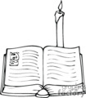
it is in pardoning that we are pardoned;
and it is in dying that we are born to eternal life.

PRESIDER: Announces the Chapter is closed.

One Alternate Reading that may be used:

Spiritual Assistant: Reading 2 Celano 125 and 145 True and Perfect Joy.
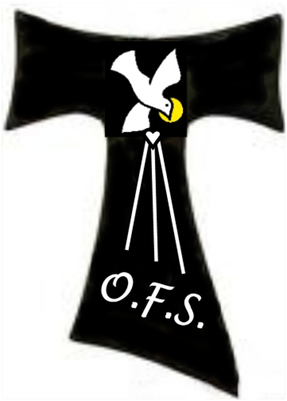
Brother Leo related, in the same place (the Portiuncula) that one day at St. Mary the blessed St. Francis called Brother Leo and said: ‘Brother Leo, write!’ He answered: ‘I’m ready.’ ‘Write.’ (Francis) said, ‘what true joy is:. ‘A messenger comes and says that all the masters in Paris have come into the Order: write: This is not true joy. Or that all the prelates beyond the mountains (have entered the Order: write: ‘This is not true joy. Again, that my brothers have gone to the nonbelievers and converted all of them to the faith; again, that I have so much grace from God that I heal the sick and perform many miracles: ‘I tell you that true joy does not consist in any of these things.’ ‘What then is true joy?’ ‘I return from Perugia and arrive here in the dead of night; and it is wintertime, muddy and so cold that icicles have formed on the edges of my habit and keep striking my legs, and blood flows from such wounds, I come to the gate, and after I have knocked and called for some time, a brother comes and asks: “Who are you?” I answer: “Brother Francis” And he says, “Go away, this is not a proper hour for going about, you may not come in.” And when I insist, he answers: “Go away, you are a simple and a stupid person; we are so many and we have no need of you. You are certainly not coming to us at this hour!” And I stand again at the door and say “for the love of God, take me in tonight.” And he answers, “I will not. Go to the Crosiers” place and ask there.” I tell you this, If I had patience and did not become upset, there would be true joy in this and true virtue and the salvation of my soul.

WELCOME
Secular Franciscan, Servant Leaders!
May the Holy Spirit guide all of you as you journey together.

